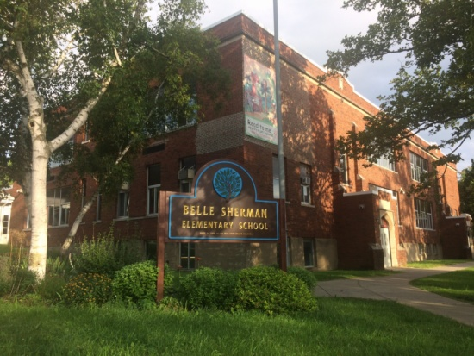

MINIMUM CAPACITY :-
The Minumum intake capacity
of students is between 300-920
children

LIBRARY :-
The Libarary is Available.

CANTEEN:-
The Canteen Facility is Available.

BOARDING :-
No availablility of boarding.

SPORTS :-
There are different categories
sports available.
Girls Volleyball
Boys Volleyball
Football

BELLE SHERMAN ELEMENTARY SCHOOL
ITHACA - SCHOOL

School Detail :-
Belle Sherman School is a public school located in Ithaca, NY, which is in a small city setting. The student population of Belle Sherman School is 316 and the school serves PK-5. At Belle Sherman School, 62% of students scored at or above the proficient level for math, and 47% scored at or above that level for reading.

